### Basic Requirements:

* Do it in html using bootstrap.
* Check the websites.
* Font: <https://fonts.google.com/noto/specimen/Noto+Sans>
* border radius 10
* Color palette: <https://coolors.co/0d0f50-1ac8ed-fe7f2d-fcfcfd>

### 

1. <https://otter.ai/signin>
2. <https://otter.ai/signup>
3. Onboarding: Just sign up and see the onboarding pages from happyscribe:<https://www.happyscribe.com/users/sign_up>
   1. 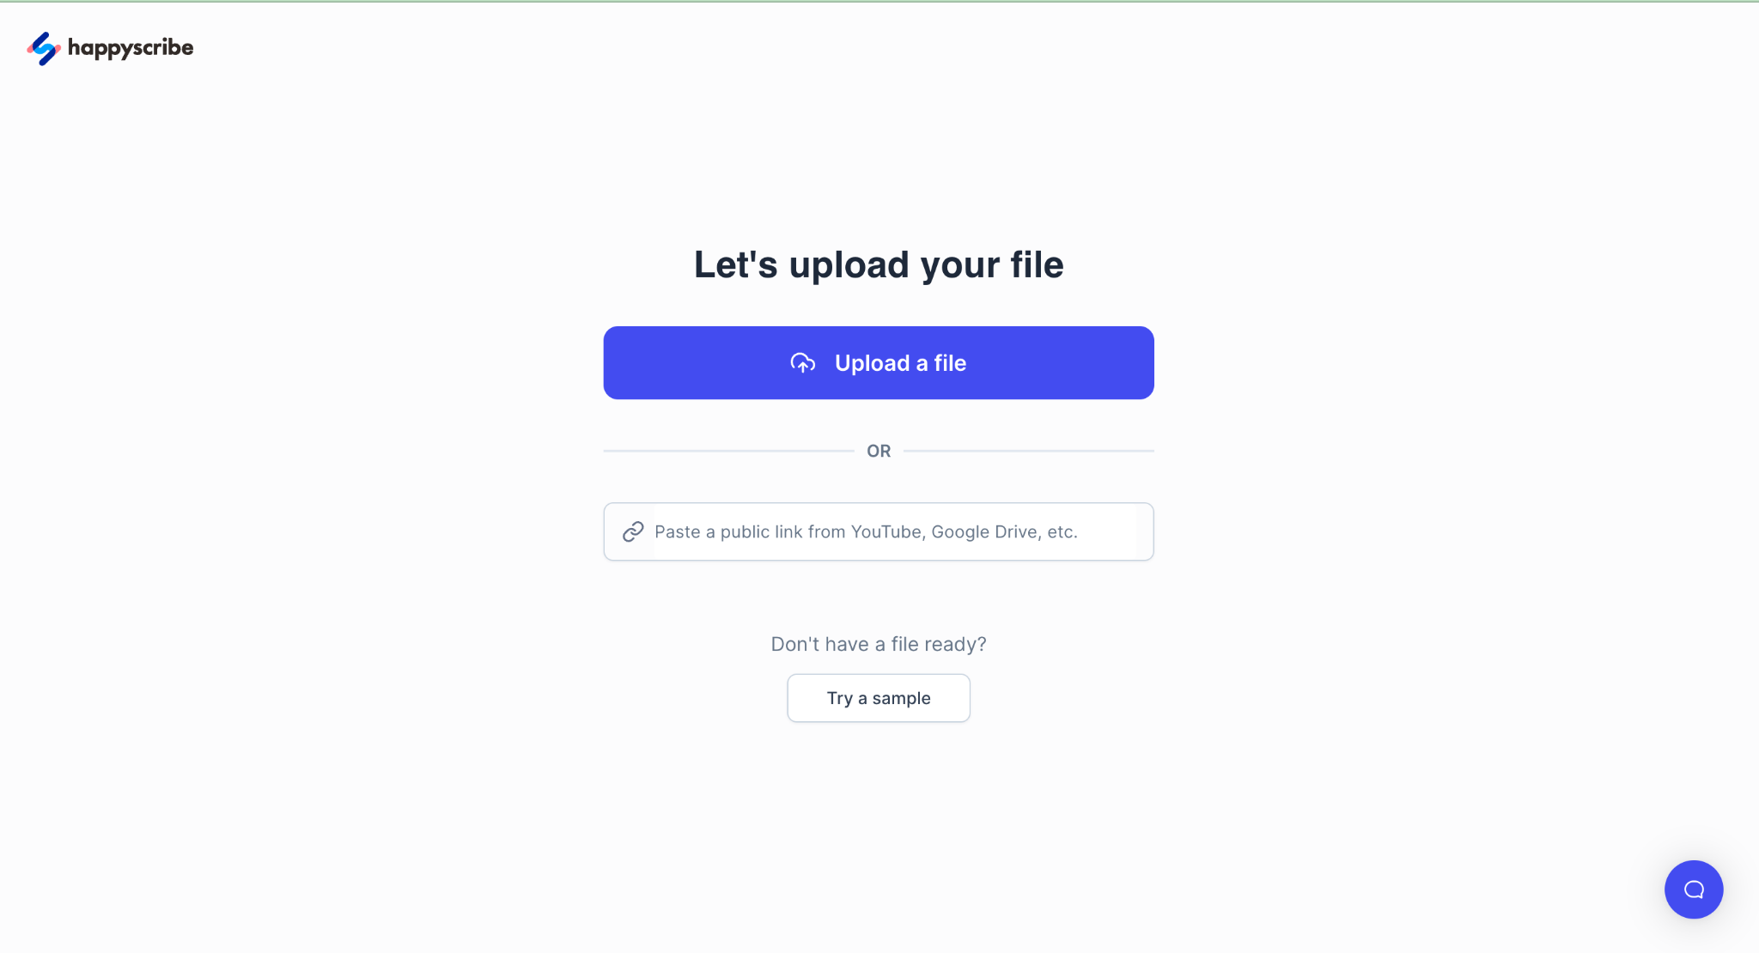
   2. 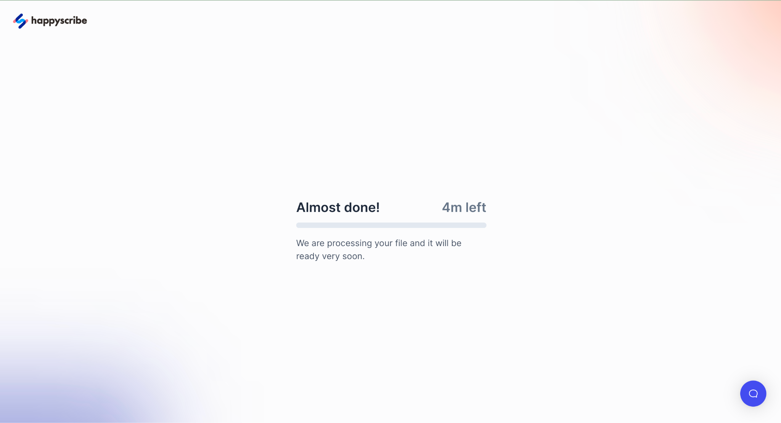
4. Transcript single view: Otter
5. Pricing: Notta | sign up and try to upgrade: <https://www.notta.ai/en>
6. Home: Otter
7. My conversations: Otter
8. Settings: Otter